**Urban Population Growth Prediction Project**

**Executive Summary:**

This project addresses the critical challenge of predicting urban population growth, a vital aspect for effective urban planning and resource allocation. By employing advanced machine learning techniques, we aim to identify key socio-economic factors influencing population dynamics. Our findings will provide actionable insights to urban planners and policymakers.

**Project Objectives:**

* Predict population growth in urban areas using historical data.
* Analyze socio-economic factors influencing population trends.
* Provide recommendations for sustainable urban development.

**Dataset Overview:**

The dataset consists of various socio-economic indicators and population statistics, structured as follows:

| **Feature** | **Description** |
| --- | --- |
| CityID | Unique identifier for each city |
| CityName | Name of the city |
| Year | Year of observation |
| CurrentPopulation | Current population of the city |
| PopulationDensity | Density of the population per square kilometer |
| BirthRate | Birth rate per 1,000 individuals |
| DeathRate | Death rate per 1,000 individuals |
| ImmigrationRate | Rate of immigration per 1,000 individuals |
| UnemploymentRate | Percentage of unemployed individuals |
| AverageIncome | Average income of residents |
| EducationLevel | Categorical representation of education levels |
| HealthcareAccess | Index of healthcare access |
| CrimeRate | Crime rate index |
| PopulationGrowthRate | Target variable representing population growth rate |
|  |  |

**Data Preprocessing Steps**

1. **Missing Value Treatment**: Implemented strategies to handle missing values, ensuring data integrity.

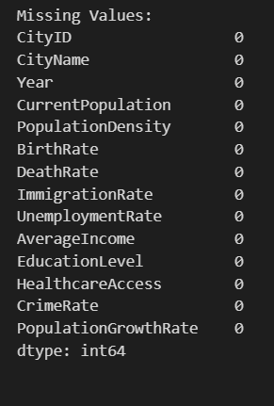

1. **Feature Encoding**: Categorical features were encoded using Label Encoding and One-Hot Encoding to prepare for model training.
2. 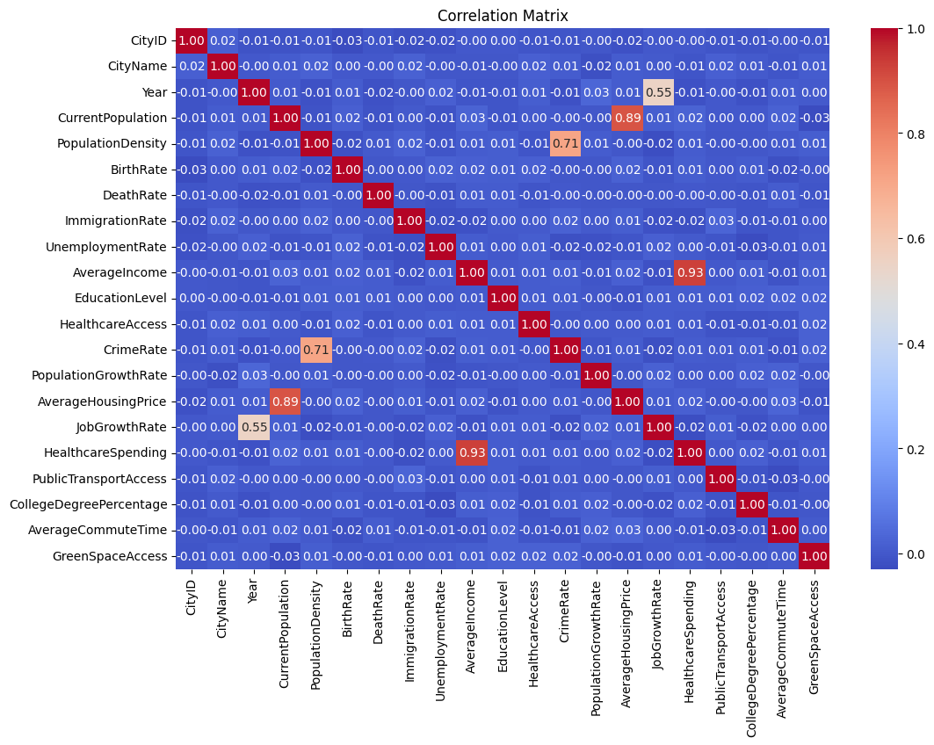**Outlier Detection and Treatment**: Outliers were identified using the Interquartile Range (IQR) method and addressed accordingly.

**Before Removal of Outlier:**

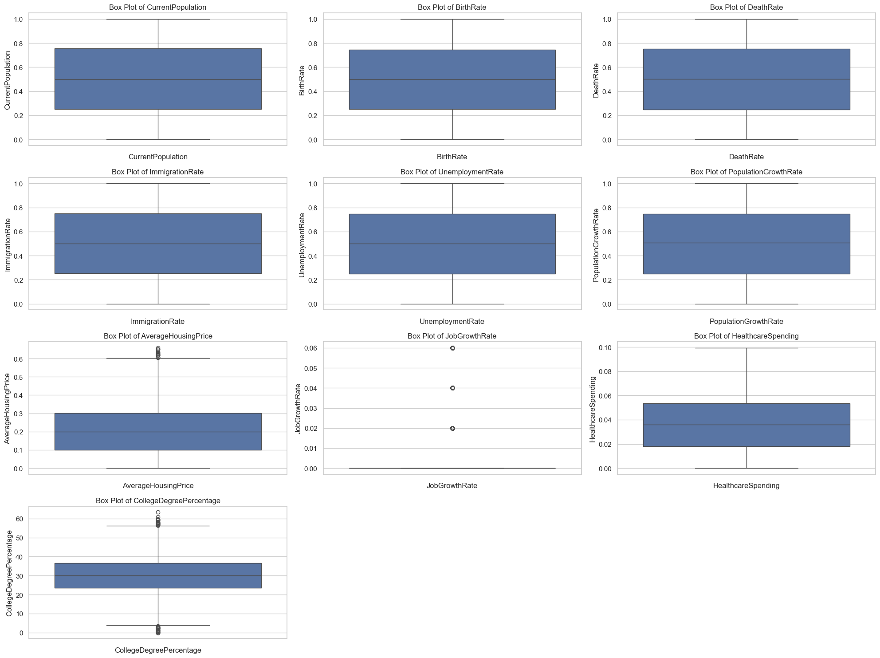

**After Removal of Outlier:**

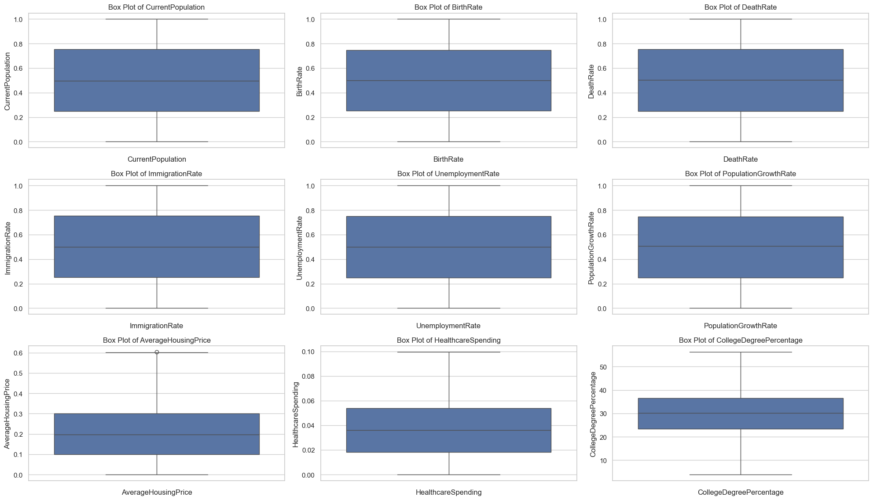

1. **Feature Scaling**: Normalization and standardization techniques were applied to ensure uniformity across features.

**Feature Engineering:**

Enhanced the dataset by creating additional features to better capture socio-economic dynamics:

* AverageHousingPrice
* JobGrowthRate
* HealthcareSpending
* PublicTransportAccess
* GreenSpaceAccess

**Model Development and Evaluation:**

A range of machine learning models were implemented to assess their effectiveness in predicting population growth:

**Models Explored:**

1. **Linear Regression**
2. **Decision Tree Regressor**
3. **Random Forest Regressor**
4. **XGBoost Regressor**

**Model Performance Summary:**

|  |  |  |  |
| --- | --- | --- | --- |
| **Model** | **Mean Squared Error (MSE)** | **Root Mean Squared Error (RMSE)** | **R-squared (R²)** |
| Linear Regression | 0.0819 | 0.2862 | 0.0019 |
| Decision Tree | 0.1734 | 0.4164 | -1.1134 |
| Random Forest | 0.0841 | 0.2900 | -0.0249 |
| XGBoost | 0.0984 | 0.3137 | -0.1991 |

**Graphs:**

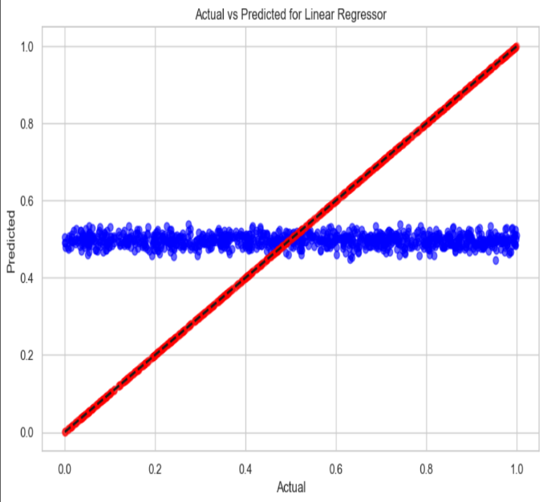 **Linear Regression**  **Decision Tree**

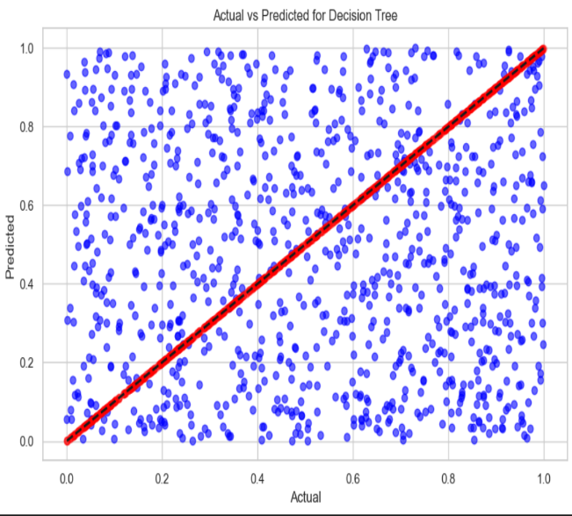

**Insights**

**Random Forest**  **XGBoost**

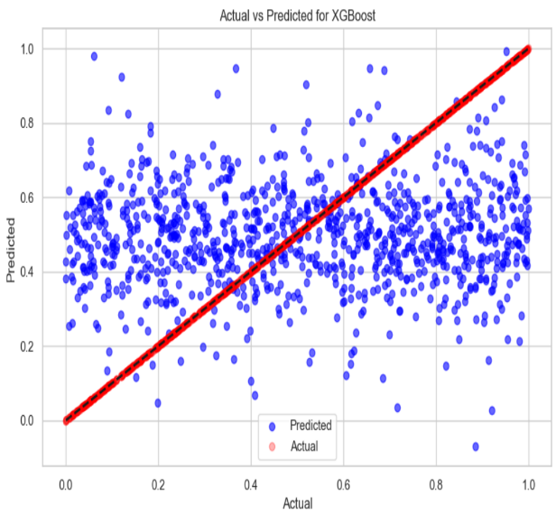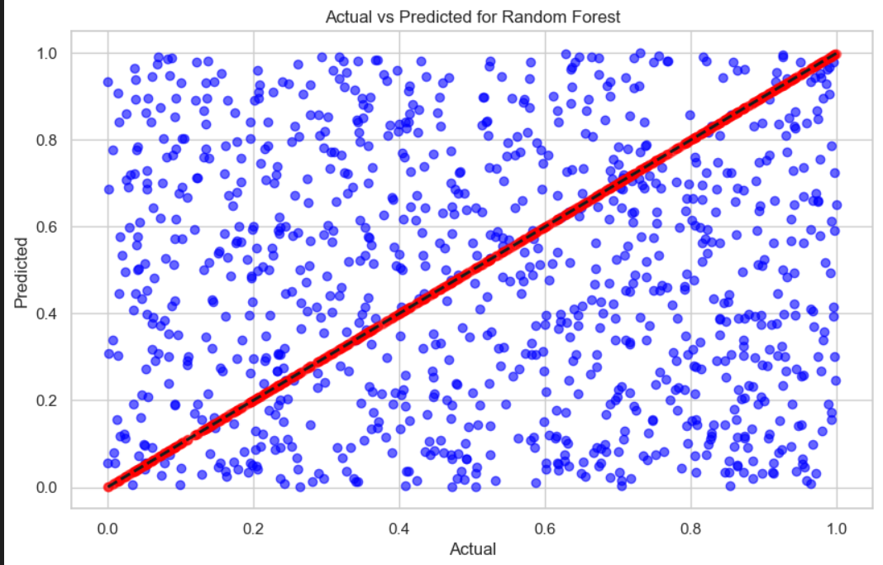

* **Top Performer**: The **Linear Regression** model outperformed all others in terms of MSE and RMSE, indicating a suitable fit for the dataset.
* **Underperforming Model**: The **Decision Tree** model yielded a negative R², suggesting inadequate predictive power.
* **Random Forest** demonstrated competitive results but fell short compared to Linear Regression.

**Strategic Recommendations:**

1. **Model Selection**: Given its performance, Linear Regression is recommended for predicting population growth.
2. **Further Enhancements**:
   * Explore hyperparameter tuning for existing models to optimize performance.
   * Investigate additional socio-economic features or data transformations.
   * Consider advanced ensemble methods for improved predictive accuracy.

**Conclusion:**

This project underscores the significance of leveraging machine learning for urban planning. Our findings will aid city planners in understanding and responding to population growth dynamics effectively.

**Future Work:**

1. Explore More Algorithms: Experiment with advanced models like Neural Networks and LightGBM for improved predictions.
2. Optimize Models: Use hyperparameter tuning techniques like Grid Search to enhance model performance.
3. Enhance Features: Identify and incorporate new features that may significantly influence urban population growth.
4. Long-Term Analysis: Conduct studies on historical data to better understand the impact of socio-economic factors over time.
5. Build a Dashboard: Develop an interactive application for real-time predictions and insights to support urban planning.

**Code Repository:**

The complete implementation is available in the accompanying Jupyter Notebook or Python script, accessible via the project's GitHub repository.